Name of the Student | SANJAYDHARAN V
Reg. No | 192425002
GitHub Link | https://github.com/192425002simats-dev/MLA0405-DEEP-LERANING-/tree/main/ASSESMENTS

SIMATS ENGINEERING
CO3 - ASSESSMENT TOOL 2
Game Based Learning
COURSE NAME: DEEP LEARNING COURSE CODE: MLA04
SLOT :

COURSE OUTCOME COVERED
CO3: Analyze and apply convolutional neural network architectures, including convolutional layers, filters, parameter sharing, regularization, AlexNet and ResNet, to develop solutions for image classification and real-world computer vision applications. (L4)
CO Weightage: 25% Duration: 1 Hour
Assessment Tool Weightage: 35% Marks: 50

Code of Conduct:
I SANJAYDHARAN V 192425002 (Name / Reg No) certify that this submission is my original work and that I have adhered to the guidelines specified for this assessment.
I understand that any violation of academic integrity rules will result in disciplinary action.
SANJAY DHARAN V
Signature of the student:
Name of the student:SANJAYDHARAN V

Criteria | Understanding of Concept  (2.5) | Conceptual Clarity (2.5) | Problem-Solving Ability (2) | Solution Design & Application (2) | Teamwork & Game Participation (1) | Total (10)
Weightage | 25 % | 25% | 20% | 20 % | 10 % | 100%
Round 1
Round 2
Total

Signature of the Faculty: Total Marks :

QUESTIONS:01 Total Marks: 50

Question:

Design and participate in a two-round game-based learning activity to explore the fundamental concepts of Convolutional Neural Networks (CNNs), including architecture, layers, filters, parameter sharing, regularization, AlexNet, ResNet, and real-world applications. Progress through five levels in each round, applying your knowledge to solve challenges involving CNN design, feature extraction, architecture comparison, and practical applications.

The Game Progression
Round 1:
Basic CNN Concepts → Filters → Parameter Sharing → Architecture → AlexNet vs ResNet
Round 2:
Convolution → Feature Maps → Regularization → Architecture Comparison → Real-World Application

ROUND 1: CNN Architecture Builder (Learn by constructing and understanding CNN architectures layer by layer)
Level | Challenge | Description
Level 1 | CNN Layer Matcher | Match CNN layers such as Convolution, Pooling, Flatten, and Fully Connected layers with their respective functions and roles in the network.
Level 2 | Filter Finder | Identify suitable filters and kernels for feature extraction and understand how filter size, stride, and padding affect the output feature map.
Level 3 | Parameter Sharing Puzzle | Determine how the same filter weights are reused across different image locations and calculate the number of parameters in a convolutional layer.
Level 4 | CNN Architecture Debugger | Identify and correct problems in a CNN architecture, such as incorrect layer order, incompatible dimensions, and inappropriate layer selection.
Level 5 | AlexNet vs ResNet Challenge | Compare AlexNet and ResNet architectures and identify how their architectural approaches differ, particularly the use of residual connections in ResNet.

ROUND 2: CNN Feature Detective ( Learn by exploring how CNNs extract features, avoid overfitting, and solve real-world problems)
Level | Challenge | Description
Level 1 | Edge Detection Explorer | Apply simple (3\times3) filters to an image and determine how convolution operations can detect edges and other basic features.
Level 2 | Feature Map Detective | Analyze feature maps produced by different CNN layers and identify the progression from simple features such as edges to complex patterns and objects.
Level 3 | Regularization Rescuer | Identify overfitting in a CNN model and select suitable regularization techniques to improve generalization and model performance.
Level 4 | CNN Architecture Race | Compare ResNet and AlexNet for different image-classification applications and determine which architecture is more suitable for a given problem.
Level 5 | CNN Application Master | Design a CNN-based solution for a real-world application such as medical image analysis, face recognition, object detection, or autonomous driving, and justify the selected architecture and layers.

🎮 ROUND 1 — CNN Architecture Builder
Level | Challenge | Game Task | Expected Learning
1 | 🧩 CNN Layer Matcher | Match Convolution, Pooling, Flatten, Fully Connected with their functions. | Understand the role of each CNN layer.
2 | 🔍 Filter Finder | Given different kernels such as edge, sharpening, and blur filters, identify which feature each detects. | Understand filters, kernel size, stride, and padding.
3 | 🔄 Parameter Sharing Puzzle | Calculate parameters in a convolution layer and explain why the same filter is reused at different locations. | Understand parameter sharing and computational efficiency.
4 | 🛠️ CNN Architecture Debugger | Find errors such as incorrect layer order, incompatible dimensions, or inappropriate layers and correct them. | Apply CNN architecture concepts to solve problems.
5 | ⚔️ AlexNet vs ResNet | Compare the two architectures and identify when residual connections are useful. | Understand architectural evolution and residual learning.
🎯 Sample Challenges
Level 1 – Layer Matcher
Match:
- Convolution → Extracts features using learnable filters
- Pooling → Reduces spatial dimensions
- Flatten → Converts feature maps into a 1D vector
- Fully Connected → Performs final classification
Level 2 – Filter Finder
Given a 3×3 kernel designed to emphasize horizontal intensity changes, the player must identify:
Answer: Horizontal edge detection.
The player also determines how changing stride and padding affects the feature-map size.
Level 3 – Parameter Sharing
For a convolution layer with:
- Input channels = 3
- Number of filters = 16
- Kernel size = 3×3
Parameters:
(3×3×3+1)×16 =448
Answer: 448 parameters.
The key concept is that each filter's weights are reused across different spatial locations.
Level 4 – Architecture Debugger
Example:
Input Image → Fully Connected → Convolution → Pooling → Output
❌ Incorrect.
A better architecture is:
Input → Convolution → Activation → Pooling → Flatten → Fully Connected → Output
Level 5 – AlexNet vs ResNet
Feature | AlexNet | ResNet
Year | 2012 | 2015
Main idea | Deep CNN with convolutional layers | Deep CNN with residual learning
Skip connections | ❌ No | ✅ Yes
Very deep networks | More difficult | Easier to train
Key concept | Deep convolutional architecture | Residual/skip connections
Winning condition: The player correctly explains why ResNet's skip connections help with very deep networks.

🔬 ROUND 2 — CNN Feature Detective
Level | Challenge | Game Task | Expected Learning
1 | 🕵️ Edge Detection Explorer | Apply 3×3 filters to an image and determine the detected edges. | Understand convolution and feature extraction.
2 | 🗺️ Feature Map Detective | Examine feature maps from different layers and identify what features are being learned. | Understand hierarchical feature extraction.
3 | 🛡️ Regularization Rescuer | Diagnose overfitting and select appropriate regularization methods. | Understand dropout, data augmentation, and regularization.
4 | 🏎️ CNN Architecture Race | Choose between AlexNet and ResNet for different classification scenarios. | Compare architectures and justify selection.
5 | 🌍 CNN Application Master | Design a CNN solution for a real-world problem. | Apply CNN concepts to practical applications.
🎯 Sample Challenges
Level 1 – Edge Detection Explorer
Given an image and a 3×3 kernel, calculate the convolution at a selected location.
The player must determine whether the filter detects:
- Vertical edges
- Horizontal edges
- Diagonal edges
- Blurring
Level 2 – Feature Map Detective
The player receives three feature maps:
Layer 1 → Layer 2 → Layer 3
Expected interpretation:
Layer 1: Edges and simple textures
↓
Layer 2: Shapes and patterns
↓
Layer 3: Object parts and complex structures
This demonstrates the hierarchical feature extraction property of CNNs.
Level 3 – Regularization Rescuer
Example:
Training accuracy = 98%
Validation accuracy = 76%
The player identifies:
Overfitting
Possible solutions:
- Dropout
- Data augmentation
- L2 regularization
- Early stopping
- More training data
Level 4 – CNN Architecture Race
Example scenario:
"A company needs a deep image-classification model that can effectively train many layers."
Recommended choice: ResNet
Reason:
Residual/skip connections help information and gradients flow through very deep networks, making deep models easier to optimize.
Level 5 – CNN Application Master
Example:
Problem: Detect tumors from medical images.
A suitable solution:
Medical Image → Preprocessing → Convolution → ReLU → Pooling → Multiple CNN Blocks → Flatten/Global Average Pooling → Fully Connected Layer → Tumor Classification
The player must justify:
- Why CNN is suitable
- Which layers are used
- Why the selected architecture is appropriate
- How overfitting will be controlled
- What evaluation metrics should be used

🏆 Game Scoring System
Each level can be awarded 10 points.
Round | Levels | Maximum
Round 1 | 5 | 50
Round 2 | 5 | 50
Total | 10 | 100
Performance Levels
Score | Performance
90–100 | 🏆 CNN Master
75–89 | 🥇 CNN Expert
60–74 | 🥈 CNN Explorer
40–59 | 🥉 CNN Beginner
Below 40 | 🔄 Needs Improvement

📊 Rubric-Based Calculation
Your given rubric has a total weight of 100 marks:
Criterion | Weight
Understanding of Concepts | 25
Conceptual Clarity | 25
Problem-Solving Ability | 20
Solution Design & Application | 20
Teamwork & Game Participation | 10
Total | 100
For example, if a team receives:
- Understanding = 22/25
- Conceptual Clarity = 21/25
- Problem Solving = 17/20
- Solution Design = 18/20
- Teamwork = 9/10
Final score = 87/100
Performance: Level 3 – Proficient
Suggested Game Rule
For each challenge, award:
- Level 4 – Exemplary: Full marks
- Level 3 – Proficient: 75% of available marks
- Level 2 – Developing: 50% of available marks
- Level 1 – Beginning: 25% of available marks

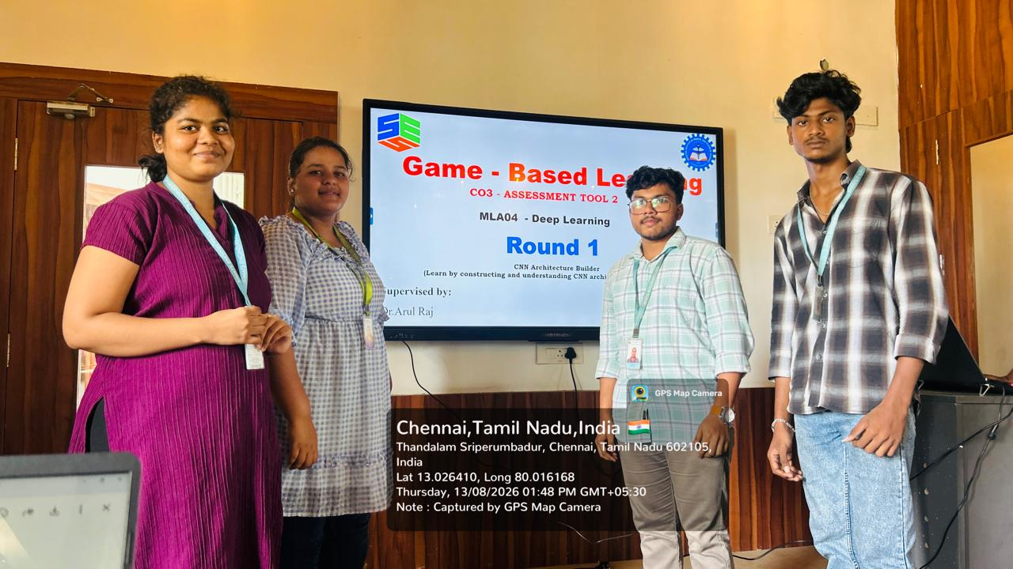

RUBRICS FOR CALCULATION:

Criteria | Weightage | Level 4 – Exemplary | Level 3 – Proficient | Level 2 – Developing | Level 1 – Beginning
Understanding of Concepts | 25 | Thorough understanding; clearly identifies all key issues | Good understanding with most issues identified | Basic understanding; some issues missed | Poor understanding; problem not identified correctly
Conceptual Clarity | 25 | Effectively applies relevant concepts to analyze the case deeply | Applies appropriate concepts with minor gaps | Limited application of concepts | Fails to apply relevant concepts
Problem-Solving Ability | 20 | In-depth analysis with strong reasoning and insights | Good analysis with logical reasoning | Basic analysis with limited depth | Weak or no analysis; lacks reasoning
Solution Design & Application | 20 | Innovative, feasible solutions with strong justification | Logical solutions with adequate justification | Basic solutions with weak justification | Incorrect or no solution provided
Teamwork & Game Participation | 10 | Clear, well-structured, and easy to understand | Organized and understandable presentation | Limited clarity and structure | Poor clarity; difficult to understand

